8th International Conference-Workshop on Sustainable Architecture & Urban Design (ICWSAUD2025)

8th International Conference on Engineering, Innovation & Technology (ICEIT2025)
ICWSAUD2025 – ICIET2025

http://icwsaud.com

8-9 May 2025, Bangkok, Thailand

Article ID:

Title of the Paper with Capitalized Each Word and No Comma Allowed

Firstname LastName^{1*}, FirstName LastName², FirstName LastName¹, FirstName LastName³

¹ Department or Institue or Faculty or Center must be given, University of Great Wall Research, CHINA.
² Centre for Instruction, Technology and Management, University of Extensive Research, Penang, MALAYSIA.
³ Department or Institue or Faculty or Center must be given, University of Big River, Nakorn Nayok, THAILAND.
*Corresponding Author (Tel: +966 123 456, CorrepsondingAuthorEmail@UniversityeMail.Edu)
Keywords:  Must not be part of paper’s title; Please put 10 keywords re more; At least five keywords; Separated by a semi-colon. | Abstract  This abstract should less than 200 words. Be precise and concise, the abstract should summarize your study and findings. Do not change any format. After done, please save as “docx” file. This template explains how to format and write your manuscript. The paper must not have any kind of break (section break, page break).  Disciplinary: Put All Relevant Field of Study, Put a Comma between Each Field.

Introduction
Do not change any format of this file. Section break and page break are not allowed.

Information
Each paper must have less than 5000 words including everything. Click “Normal” for all paragraph writings (Thiandee et al., 2019), see Figure 1.
All Figure images must be sharp of high quality, with clear big texts. Grouped text boxes are preferable.

Instruction
Other instructions are given below.
- All Tables are in a form of cells (texts), not box or border or image, please put all the units.
- Images must be of high quality (preferably 300+ dpi), with big font readable texts/symbols and units.
- ITJEMAST publishes only new materials (except that you create to put in your thesis/dissertation and a note is needed).
- Plagiarism checks:: Each and all manuscripts, Turn-It-In and/or other engines are used for similarity checks. ITJEMAST allows 12-15% Turn-It-In score, for 5 consecutive words checking. Images and other materials are randomly checks.
- ITJEMAST requires each and all authors to give their photos and brief authors' bio to put at the end of the published manuscript. Bio = Status (student/professor) + Education + Research interests.
- Paper has no footnotes (NOT allow footnotes).
- We accept many types of reference format and citation writing.
  - The paper uses only the last name of authors. Citation writing, this paper uses “et al.” for all places for citing a paper with 3 authors and more, followed by year.
  - Citation writing, this paper can uses square blankets as well [2] or [5, 8, 9].
  - All reference items must be of the same style format (such as APA, Harvard, etc.).
  - All references items must be cited/mentioned in your writing.
  - Delete all non-mentioned reference items.
  - Citation check: All cited/mentioned others' works must be found in References list.
- Make sure statistic data/interpretation of the result. You have to check your and conclude your hypotheses (Accepted or Rejected).
- Result: Please show only 2-3 decimals. Is it meaningful to show many decimals? (Your results have how many significant figures?)
- In this paper, Equations, Table, and Figure are sequentially numbered. Table 1, Table 2, Table 3, ... Table 10. Figure 1, Figure 2, Figure 3, ... Figure 10. For Equation, please put (1), (2), … at the end on the right-side of the Equation.
  - All Tables and Figures must be mentioned/explained in writing.
  - Tables and Figures are mentioned by number (not accepted Table below, Figure above)
  - Delete all not mentioned/explained Tables/Figures.
- Please explain all the symbols, subscripts, and superscripts used in the paper.
- Please give the full terms of abbreviations.
- All the graphs contain titles of x and y-axis, with units.
- Keywords: Please give 10 keywords that are not part of the paper’s title.
- The corresponding name and email are given. Email must contain the name.
- Please, authors must also send the signed copyright form http://TuEngr.com/CopyrightTransferAgreement2021.pdf
We will return the manuscript back to you if you do not follow this guideline.
For final submission, after we publish your paper, we will NOT allow changes (including not allow adding authors and order changes). **We will allow only critical corrections. MAKE SURE YOUR Coauthors/Advisor AGREE

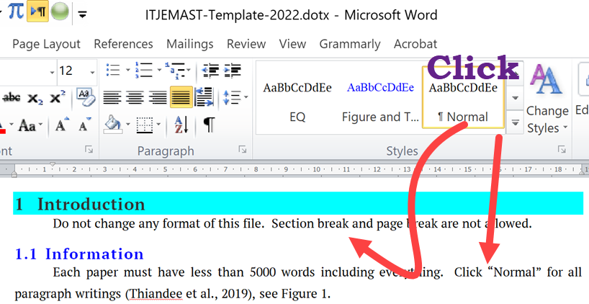
Figure 1: Click Figure and Table from the style box in Word, it should show font size 12.

Literature Review
Recent literature should be reviewed and cited (Anantakarn, et al, 2019). All the writing should be concise and precise. No need to put the general knowledge. We will check all papers for plagiarism using software such as TurnItIn® or iTthenticate® or Grammarly® or others. Copyright transfer file must be accompanied by the manuscript. The publication time may vary, depending on the quality of each paper that corrections are required.
$Q = \frac{{m_{0}-m}_{s}}{m_{s}}$ (1),
where Equation is considered as a part of the sentence. Please make sure that all symbols are explained.

Click Heading 2 from the Styles Format for the Sub-topic
See Figure 2 for Heading 2, the format will be set automatically.

Heading 3 (Click Heading 3 from the Styles Format for the Sub-subtoic)
Click Heading 3 as shown in Figure 2.
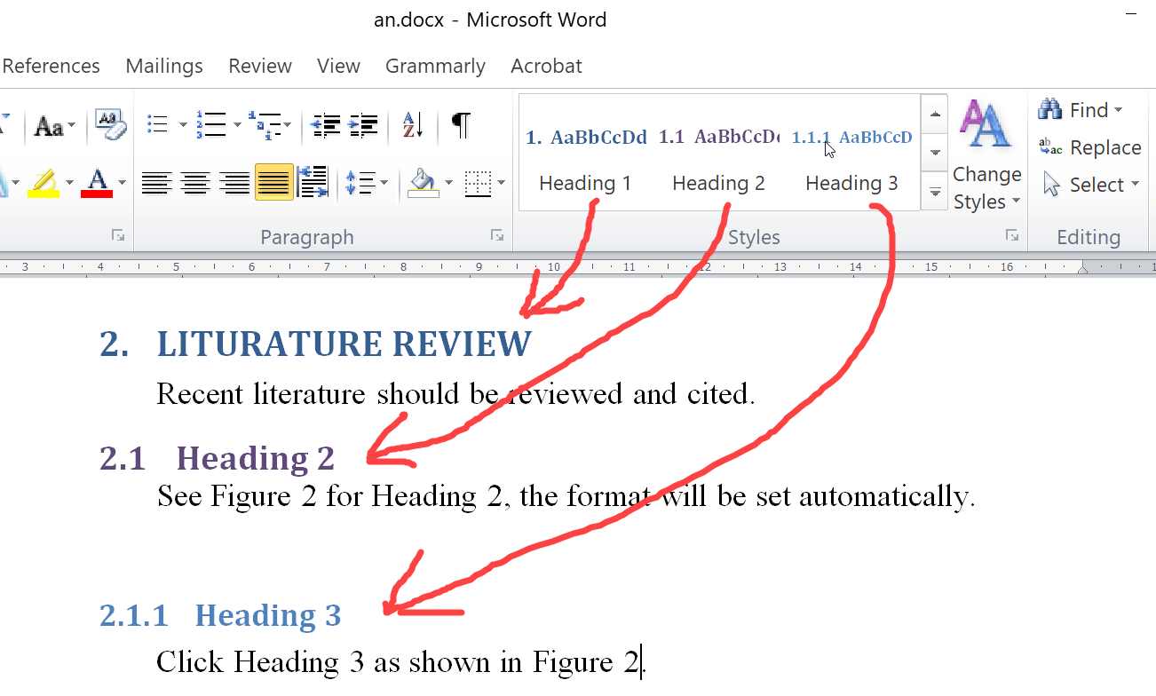
Figure 2: Just click from Styles in the Home tab.

Method

Figure and Table
Figure and Table is not a topic in your paper. We put it here only to explain the detail. Author should select “In line with text” for Figure and Table (Click Figure or whole Table that you want to set a Format Format tab Wrap Text In line with text). Figure and Table can be automatic set center by click “Figure and Table” from Styles, see Figure 3.

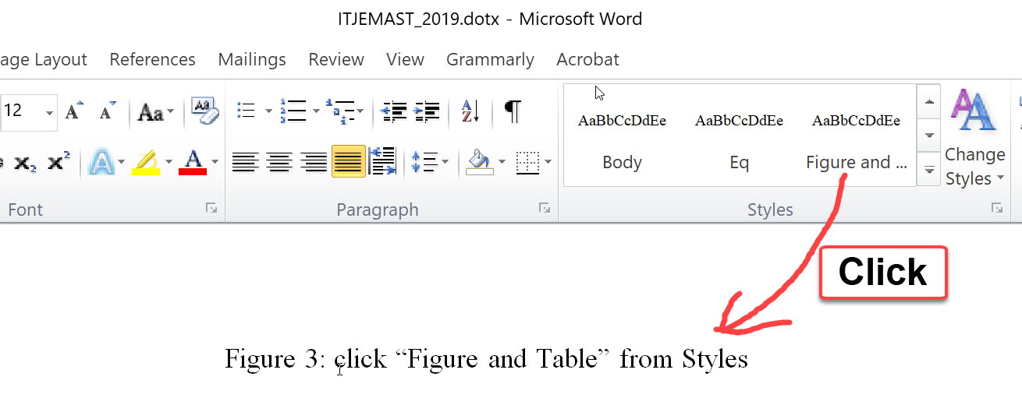
Figure 3: click “Figure and Table” from Styles

Result and Discussion
Data result in Table 1 uses “Text Size 10” (click Table2 in the Styles format). Please explain all symbols in Equations, Figures, and Table.

Table 1: Analyzed result (click Figure and Table in the Styles format, get font size 12).
Please put units.
Item | Mean | SD | p-value (Click Table2)
1 | 0.61 | 0.16 | 0.14
2 | 0.16 | 0.10 | 0.03
3 | 0.40 | 0.08 | 0.48

Conclusion
Be concise and precise to summary your study. Important findings from your study are reported and emphasized here. The conclusion should not longer than 300 words.

Availability of Data and Material
Data can be made available by contacting the corresponding authors.

Acknowledgement
The authors appreciate the financial supports from the Double Twin Foundation, under the contract number FG2021-987.

References
We accept all reference styles (APA format, Harvard format, Vancouver format, MLA format, IEEE format, or Chicago format. Do not mix between format). All reference items must be the same style.
Thiandee, P., Witchayangkoon, B., Sirimontree, S., Lertworawanich. (2019). An Experiment on Measurement of Pavement Roughness via Android-Based smartphones. International Transaction Journal of Engineering, Management, & Applied Sciences & Technologies. 10(9), 10A09G, 1-9.
Anantakarn, K., Sornchomkaew, P., Phothong, T. (2019). Improve Quality of Global DEM for Topographic Mapping: Case Study of Petchaburi Province, Thailand. International Transaction Journal of Engineering, Management, & Applied Sciences & Technologies. 10(9), 10A09H, 1-9.

Authors’ photo and bio. Bio = Status (student/professor) + Education background + Research interests.
 | Manso Sartores is a student at Department of Computer Technology, Twin University, Iraq. He got a Bachelor’s degree in Computer and Animation Technology from Okayla Institue, Iraq. His researches are Computer Application and Modern Computer Technology such as Serverless Front-End Technology.
 | Dr.Mahoo Vanoon is an Assistant Professor at Department of ABC, EFGH Engineering University, Alor Star, Malaysia. He got his Master’s and PhD degrees in Civil Engineering from Assummed University of Alor Star, Malaysia. His research focuses on Contemporary Technology in Telecom Architecture.

